Supplementary Data
Germline whole exome sequencing of a family with appendiceal mucinous tumours presenting with pseudomyxoma peritonei

Mei Sim Lung¹, Catherine A. Mitchell², Maria A. Doyle³, Andrew C. Lynch⁴, Kylie L. Gorringe^{5,7}, David D.L. Bowtell ^{6,7,8}, Australian Ovarian Cancer Study Group, Ian G. Campbell^{1,2,7¶}, Alison H. Trainer^{1,9,10¶}

¹Cancer Genetics Laboratory, Peter MacCallum Cancer Centre, Melbourne , Victoria, Australia
²Department of Pathology, Peter MacCallum Cancer Centre, Melbourne, Victoria, Australia
³Research Computing Facility, Peter MacCallum Cancer Centre, Melbourne, Victoria, Australia
⁴Department of Surgical Oncology, Peter MacCallum Cancer Centre, Melbourne, Victoria, Australia
⁵ Cancer Genomics Program, Peter MacCallum Cancer Centre, Melbourne, Victoria, Australia
⁶Cancer Genetics and Genomics Laboratory, Peter MacCallum Cancer Centre, Melbourne, Victoria, Australia
⁷Sir Peter MacCallum Department of Oncology, University of Melbourne, Parkville, Victoria, Australia
⁸Department of Biochemistry and Molecular Biology, University of Melbourne, Parkville, Victoria, Australia
⁹ Parkville Familial Cancer Centre, Peter MacCallum Cancer Centre, Melbourne, Victoria, Australia
¹⁰ Department of Medicine, University of Melbourne, Parkville, Victoria, Australia
¶ co-senior authors

Corresponding author
Mei Sim Lung
Research Division
Peter MacCallum Cancer Centre
Victorian Comprehensive Cancer Centre Building
305 Grattan St
Melbourne VIC 3000
Australia
E-mail address:mei.lung@petermac.org

Supplementary Data 1. Ranking of gene transcript according to predicted functional consequence of a variant
Functional Consequence | Rank
Nonsense, frameshift | 1
Essential Splice Site | 2
Missense | 3
Other | 4

Supplementary Data 2. PCR primers for validation of loss-of-function (LoF) variants and missense variants with Combined Annotation Dependent Depletion scaled score ≥10
Gene | Sequencing direction | Primer Sequence | PCR Product Size
RHBDL2 | Forward | CTGAGAAGAGGGAGGAAGCC | 244
RHBDL2 | Reverse | cctcagcctccatgactaca | 244
FGFR4 | Forward | TGGTCTTTTGGGATCCTGCT | 185
FGFR4 | Reverse | ggaggaggaggactggaaag | 185
CNTN2 | Forward | cttggcaaaggttgggtgg | 203
CNTN2 | Reverse | GACAAAGTACTGGGCATCGG | 203
RANBP2 | Forward | AAGAATGGAAAGAACGTGGGA | 220
RANBP2 | Reverse | GCAAGTTGTTCTGGTTTTGGC | 220
HSPB6 | Forward | GGAGGAGCAGGATGGAGATC | 242
HSPB6 | Reverse | gtggtcgagttcacccctc | 242
ZNF747 | Forward | GAGACCTACGGCCACCTG | 225
ZNF747 | Reverse | ACAGTTCGGCCTTCTCCTC | 225
BRINP3 | Forward | tgttcttcaagGGCTTCAAGT | 150
BRINP3 | Reverse | TCTGGAAATTTGGGACCACAG | 150
ASIC1 | Forward | GATGGCAGATGAAAAGCAGC | 244
ASIC1 | Reverse | gcctgctccttgtctcctc | 244
TNFRSF1B | Forward | CTTTCGGTCACAGCTGGAGA | 226
TNFRSF1B | Reverse | GAACTTGGCCCAGAAAGAGC | 226
RANBP6 | Forward | ACCTTCCTCTTAGATGCCGT | 236
RANBP6 | Reverse | ATCAAATTCCTGGCCAGCAC | 236
LSR | Forward | ccatgcactagggcttcag | 237
LSR | Reverse | ctcccgagaagcccaactc | 237
MTERFD3 | Forward | TGACAGCTGCACCTAATGTT | 206
MTERFD3 | Reverse | ACCTTGCTCCTGGAGAAATTC | 206
PAX1 | Forward | gtagtgatccgacgcctctg | 239
PAX1 | Reverse | CTCCGCGAGTCCTCCGATC | 239
EGFR | Forward | tctctttcacttcctacagATGC | 150
EGFR | Reverse | aggacagtcagaaatgcagga | 150
THOP1 | Forward | CTACGACGCCCAGTACTACG | 300
THOP1 | Reverse | caggccaaaggtgtgcttt | 300

Supplementary Data 3. M13 PCR primers for determination of loss-of-heterozygosity (LoH) in tumour tissue
Gene | Sequencing direction | Primer Sequence | PCR Product Size
REEP5* | Forward | GTAAAACGACGGCCAGTttgtggtccccagGTGTC | 108
REEP5* | Reverse | AACAGCTATGACCATGcGAGATGTAGGCTGGGTAGC | 108
EXOG* | Forward | GTAAAACGACGGCCAGTaagagccactaattgtgtgtgtg | 136
EXOG* | Reverse | AACAGCTATGACCATGACACCTTGCCTCTGTTCCAG | 136
RANBP2 | Forward | GTAAAACGACGGCCAGTATGGAAAGAACGTGGGATTG | 108
RANBP2 | Reverse | AACAGCTATGACCATGTTGCACAGATTTTCAATACTTGCT | 108
RANBP6 | Forward | GTAAAACGACGGCCAGTACAAATGGCTGCCGCACT | 113
RANBP6 | Reverse | AACAGCTATGACCATGCAGCCAGAATCAGTTCAATCTT | 113
TNFRSF1B | Forward | GTAAAACGACGGCCAGTAATGTGCCTTTCGGTCACAG | 110
TNFRSF1B | Reverse | AACAGCTATGACCATGTGGTTAACTGGGCTTCATCC | 110
M13 Forward Primer |  | GTAAAACGACGGCCAGT | N/A
M13 Reverse Primer |  | AACAGCTATGACCATG | N/A
*Primers also used for validation of variants in germline DNA

Supplementary Data 4. Primers for REEP5 exons
Exon | Sequencing direction | Primer Sequence | PCR Product Size
Exon 1 | Forward | AGTCGCCGCTCCAGTCTAT | 266
Exon 1 | Reverse | gagtcctctccctgcttcct | 266
Exon 2 | Forward | cgagtcgagaggaaaactcc | 292
Exon 2 | Reverse | aattgcggatgtgcagtcta | 292
Exon 3 | Forward | gaaagtgtatttgaaaatctttcattg | 298
Exon 3 | Reverse | gccacagatgcacaacattc | 298
Exon 4 | Forward | cccatccccagagtagtgaa | 364
Exon 4 | Reverse | gctgaggggtggtgataaga | 364
Exon 5 | Forward | atgatcgcacctgaacatga | 287
Exon 5 | Reverse | TGTTTCCAAGGCAACATTATT | 287

Supplementary Data 5. Coverage of familial colorectal cancer genes in whole exome sequencing
Sample | Gene | Mean coverage
P1 | APC | 74.59
P2 | APC | 73.25
P1 | BMPR1A | 154.82
P2 | BMPR1A | 201.13
P1 | EPCAM | 80.65
P2 | EPCAM | 93.60
P1 | GREM1 | 68.52
P2 | GREM1 | 92.03
P1 | MLH1 | 158.03
P2 | MLH1 | 138.76
P1 | MSH2 | 108.17
P2 | MSH2 | 105.14
P1 | MSH6 | 76.81
P2 | MSH6 | 75.05
P1 | MUTYH | 125.69
P2 | MUTYH | 88.85
P1 | NTHL1 | 172.70
P2 | NTHL1 | 127.78
P1 | PMS2 | 129.68
P2 | PMS2 | 130.68
P1 | POLD1 | 96.10
P2 | POLD1 | 85.39
P1 | POLE | 193.59
P2 | POLE | 186.60
P1 | SMAD4 | 205.47
P2 | SMAD4 | 240.61
P1 | STK11 | 3.46
P2 | STK11 | 2.08

Supplementary Data 6. Number of variants at each step of the filtering process
Sample  ID | Non synonymous variants with an allele frequency 0.15 - 0.80 | Variants not seen in 1000G or NHLBI GO ESP | Variants post local exomes filter(n=147) | Variants shared by both cases | Shared variants excluding missense variants with a CADD score<10 | Sanger sequenced validated variants
P1 | 4893 | 586 | 106 | 40 | 24 | 17
P2 | 4973 | 678 | 110 | 40 | 24 | 17
1000G,1000 Genomes Project. NHLBI GO ESP, National Heart, Lung and Blood Institute Exome Sequencing Project.

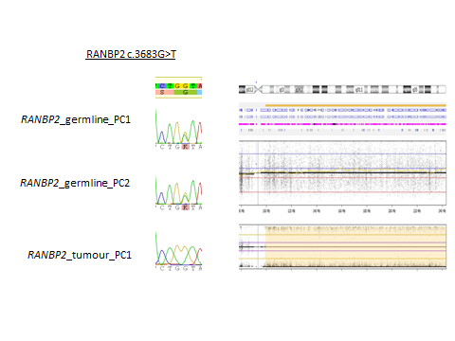
P11[Type a quote from the document or the summary of an interesting point. You can position the text box anywhere in the document. Use the Drawing Tools tab to change the formatting of the pull quote text box.]
P2
P1
Supplementary Data 7. Sanger sequencing traces for the RANBP2 missense variant in the germline of P1 (top left), germline of P2 (middle left), and tumour of P1 (bottom left), showing loss of the mutant allele.

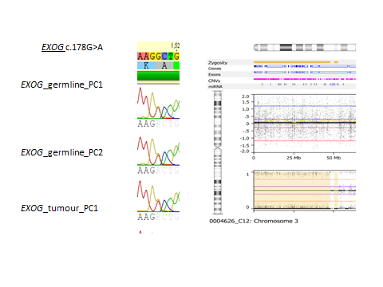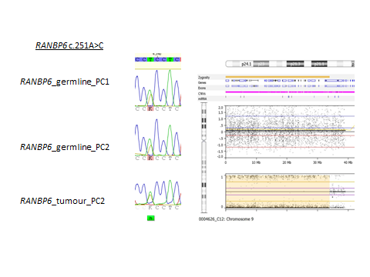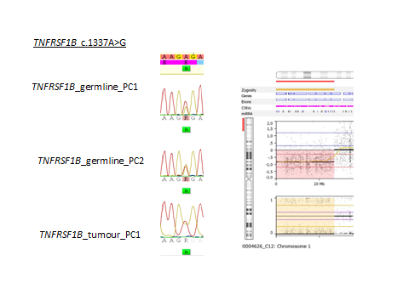
P2
P1
P1
P1
P2
P1
P2
P1
P1
Supplementary Data 8. Sanger sequencing traces for missense variants in EXOG (top panel), RANBP6 (middle panel) and TNFRSF1B (bottom panel) showing the presence of the variant in the germline of P1, P2 and in tumour from P1, despite the presence of loss of heterozygosity of approximately a)50Mbs b)30Mbs and c)loss of heterozygosity and copy number loss of approximately 20Mbs.

